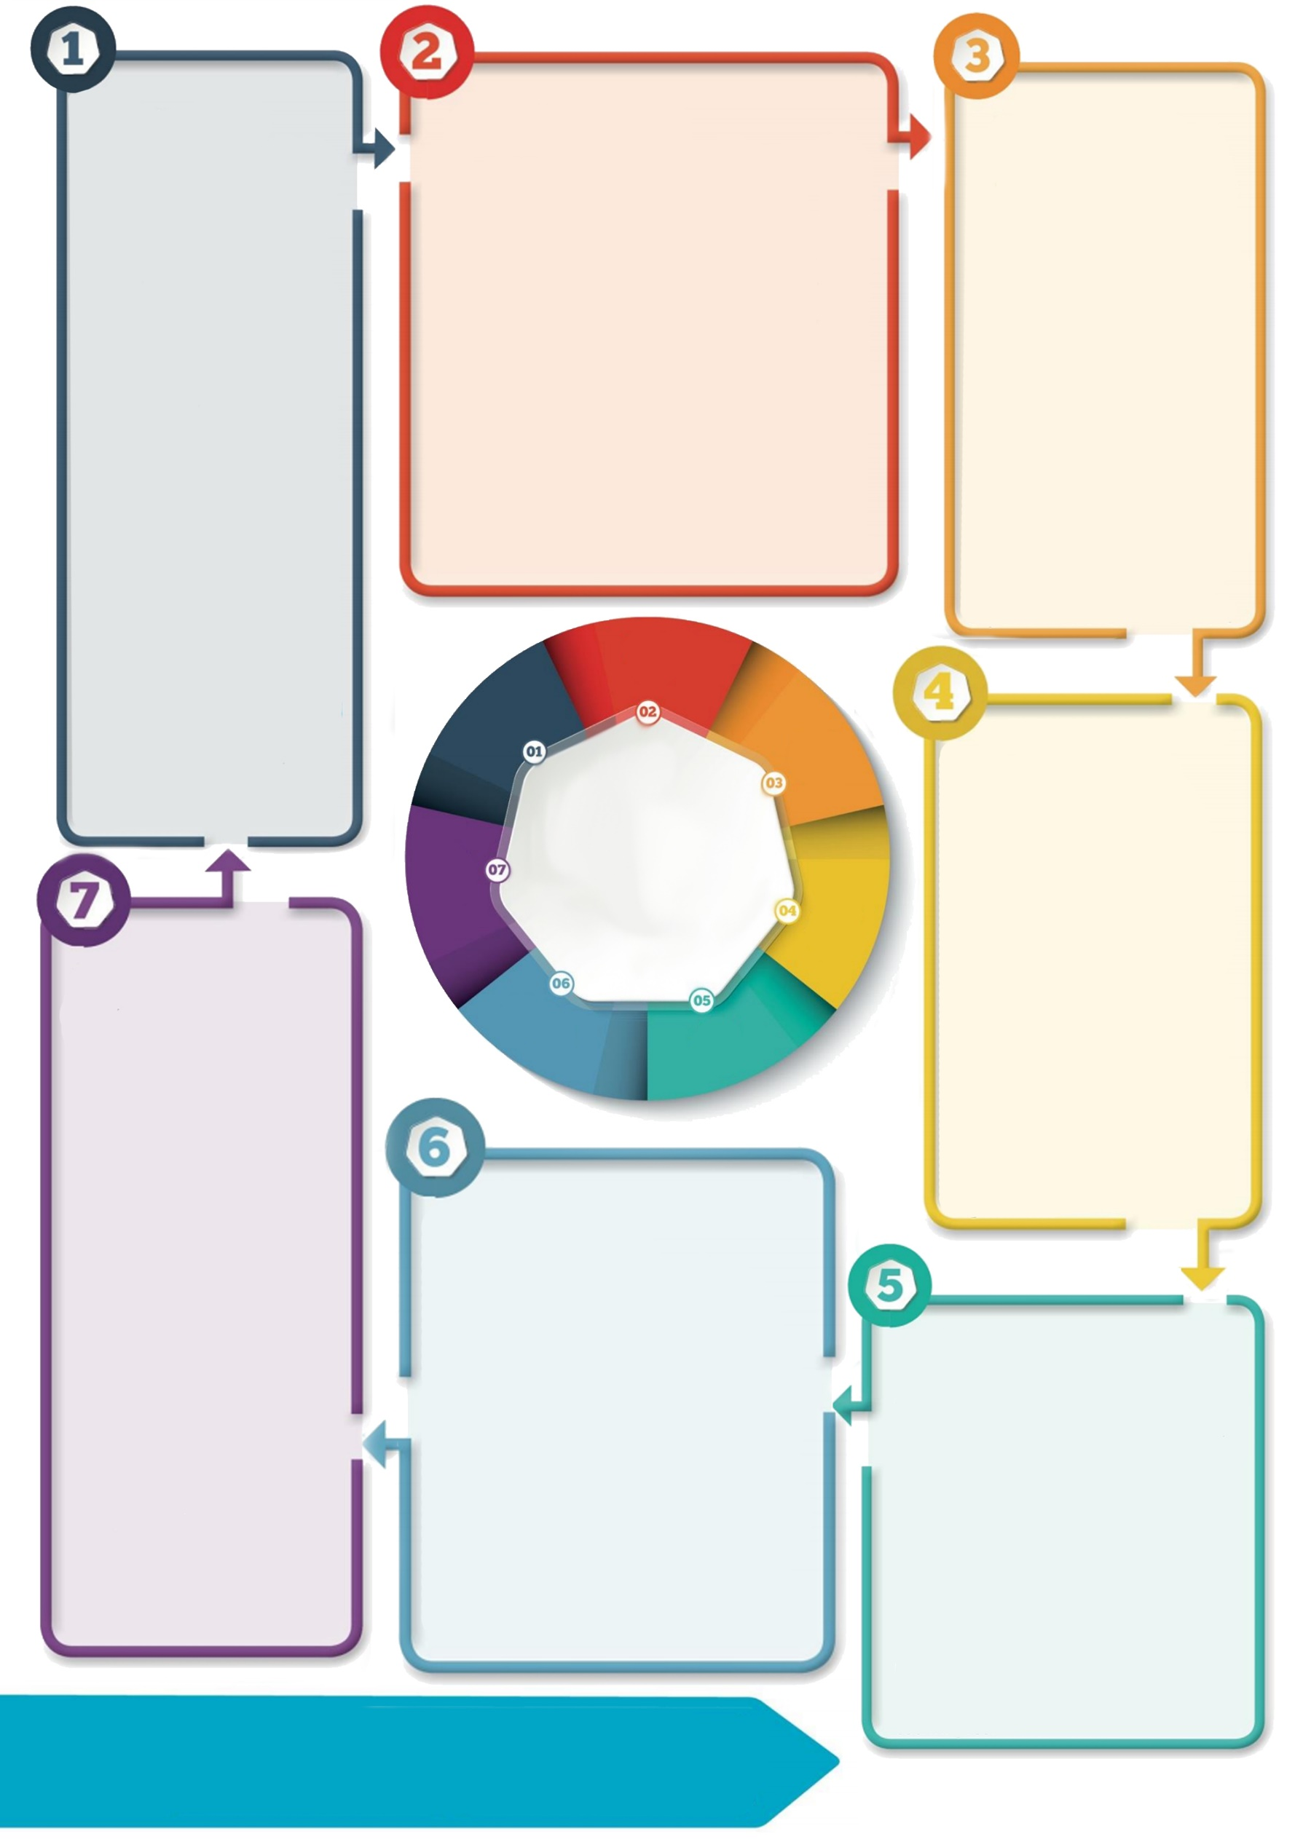

**Contact details: If you’d like to discuss further please contact the Educational Psychology Service (EPS@salford.gov.uk or educationpsychology@tameside.gov.uk)**

**Recommendations**

* Children are given time at school to play with peers, even while social distancing remains necessary. E.g. children could go outside to play in pairs or small groups on a rota system throughout the day.
* Playing and learning outdoors should be facilitated as much as possible, given the associated high benefits and lower risks.

**Play with peers**

Children have been unable to play in person with friends since March. Social interaction with peers happens primarily via play. Not having this can impact on feelings of loneliness and wider emotional wellbeing. This is likely to be hardest for children without siblings to play with, and who may already be facing marginalisation and disadvantage.

**Why it matters**

Play is an essential part of children’s development. During crisis, play can also have a therapeutic role, helping children recover a sense of normality and joy. Some children might have time, space and permission to play during lockdown, and might be playing with siblings and parents. Some children may not have these opportunities.

Children have a want, need and right to play. It is enshrined in the United Nations Convention on the Rights of the Child. Children also have the right to express views, feelings and wishes in all matters affecting them and to have these taken seriously.

**Further reading**

**Play First** [letter to government ministers](https://www.sussex.ac.uk/about/documents/play-first--supporting-childrens-social-and-emotional-wellbeing-during-and-after-lockdown.pdf) and [associated article](http://www.sussex.ac.uk/broadcast/read/51954)

**International Play Association (IPA)** <http://ipaworld.org/resources/for-parents-and-carers-play-in-crisis/>

Whilst adaptations will be needed in line with current government guidance, the outdoor play movement and policy development in Scotland may be useful to draw upon when planning [Outdoor Learning](https://education.gov.scot/improvement/Documents/hwb24-ol-support.pdf).

**Protective factors**

Play is a way for children to:

* Stay emotionally healthy
* Stay physically active
* Relax and forget about worries
* Make sense of new experiences and changes
* Cope with feelings that are difficult or frightening.

Playing can help children to feel a sense of belonging and connectedness. It helps in the moment and the longer term.

**Questions to consider**

* Can daily access to play be provided for all children, in all weather conditions?
* How can children share their views on play and what is important to them?
* Can a range of child-initiated, adult-initiated and playful experiences be provided outdoors?
* Do all staff feel able to provide time, space and permission to play, and know how to facilitate relationships, positive wellbeing and learning?
* How can expertise of Early Years staff in relation to play and learning be shared most effectively with wider team?

**Background**

Experts in children’s mental health and development are urging the government to prioritise children’s social and emotional wellbeing when easing lockdown and re-opening schools (Play First, 2020).

In the short term, there should be less focus on educational attainment and ‘catch up’, and greater focus on encouraging play to support children’s social and emotional wellbeing. This should include opportunities to play with others. Key points have been included within this briefing to consider next steps at a local level, i.e. in a primary school.

**Prioritising Play**