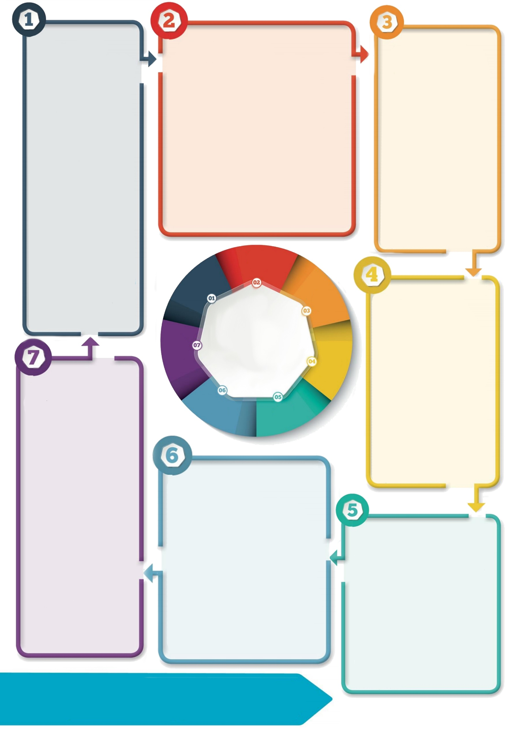

**Contact details: If you’d like to discuss further please contact the Educational Psychology Service (EPS@salford.gov.uk or educationpsychology@tameside.gov.uk)**

**Step 1: empathise, validate, label**

**(the most important step!)**

* Empathise with the child; show that you are trying to imagine how it feels for them.
* Use open body language, kind and soft facial expressions.
* Use words to reflect back the child’s emotions, providing a narrative for their experience.

E.g. *I wonder if you’re feeling worried right now because…*

*It’s normal to feel worried when… I’m here with you…*

**Step 2: limit set**

* Once the child feels understood, you may need to state a boundary limit (only if the behaviour is inappropriate). All feelings are ok but not all behaviours are ok.
* Use a calm and neutral tone.
* Unless an immediate risk to safety, you may need to spend a lot of time at Step 1 in order for the child to be receptive at Step 2.

E.g*. It’s ok to feel annoyed and it’s not ok to hurt people.*

**Step 3: Problem solve**

When the child is calm:

* Explore the feelings that led to the behaviour/problem/incident.
* Scaffold alternative ideas and actions (e.g. practise calming techniques together, discuss what you can do next time to help them prepare).
* Empower the child to believe they can overcome difficulties & manage feelings.
* Be creative in how you do this (e.g. comic strip conversations, role play).

E.g. *Next time you’re feeling like this, what can I do to help? What can we try?*

**Self-care first**

To use the oxygen mask analogy - without first attending to your own needs, you will be unable to care for others effectively.

Responding to a child’s distressed behaviours can feel frightening and threatening for adults too. Adults need to feel regulated in order to respond empathically and calmly to the child.

* Take a moment to focus on your breathing, noticing each breath, exhale longer than you inhale, until you feel a greater sense of calm.
* Pay attention to and label any sensations and emotions you are experiencing.
* What kind statements can you say to yourself that give you confidence and reassurance?

**Connecting emotionally**

When a child is upset, connect first emotionally in order to reduce their stress levels; they may be feeling threatened. How can you convey safety and containment?

Remember that all emotions are natural, normal and not always a matter of choice.

Observe, listen to and learn how the child expresses emotions; watch for changes in facial expressions, body language and tone of voice.

**What next?**

It might take adults and children some time to get used to this approach. It might feel strange at first and take some time to see the impact.

* Have a go at writing some scripts so that you feel comfortable and prepared.
* Practise with colleagues and friends.

Find out more:

* [www.emotioncoachinguk.com](http://www.emotioncoachinguk.com/)
* <https://www.bathspa.ac.uk/schools/education/research/emotion-coaching/>
* Q&A with Dr Janet Rose
* [Brene Brown on Empathy](https://www.youtube.com/watch?v=1Evwgu369Jw)
* [Good relationships are the key to healing trauma](https://www.youtube.com/watch?v=PTsPdMqVwBg)

**Emotion Coaching**

**What is Emotion Coaching?**

A technique and approach that can help children to understand and manage their emotions. It focuses on the feelings that underlie behaviours. It can be used by anyone and with anyone.

*‘Our own stress drops dramatically when we shift from trying to enforce compliance to reducing the causes of challenging behaviours and teaching kids how to do this for themselves’ (Dr Stuart Shanker).*

Emotional regulation is a skill that develops through guidance, attuned adults and practice.