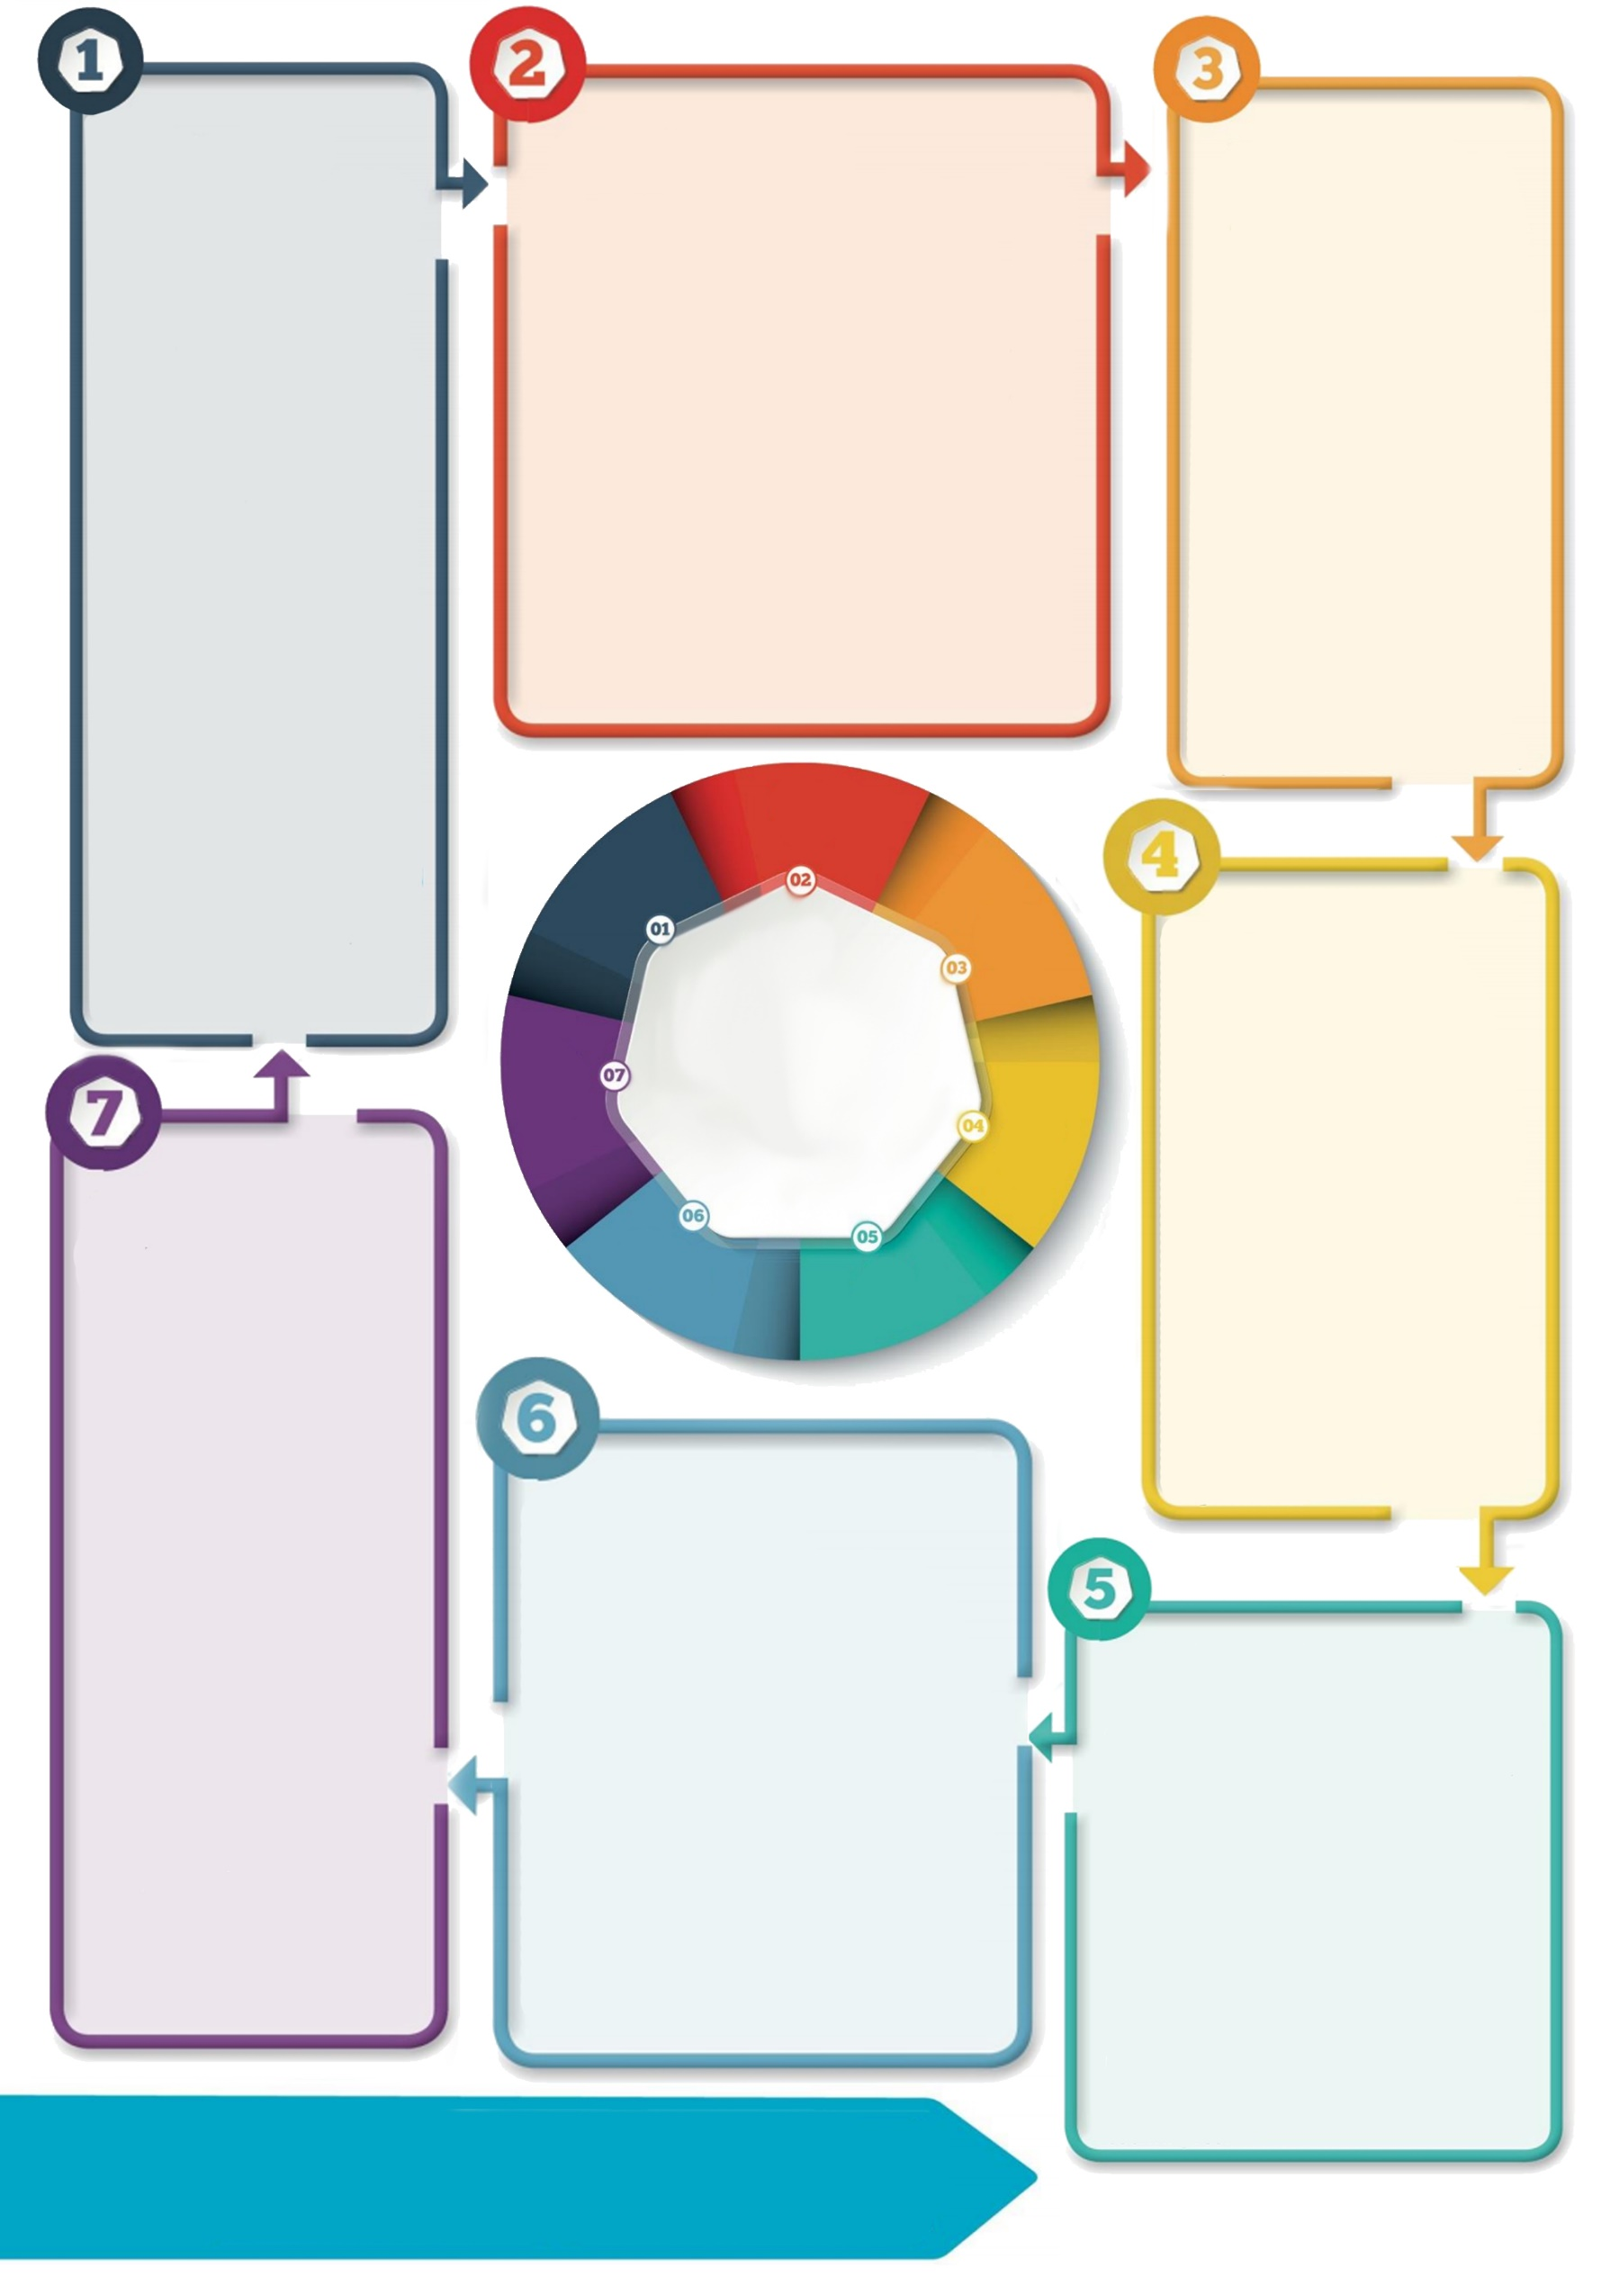

**Contact details: If you’d like to discuss further please contact the Educational Psychology Service (**[**EPS@salford.gov.uk**](mailto:EPS@salford.gov.uk) **or [educationpsychology@tameside.gov.uk](mailto:educationpsychology@tameside.gov.uk))**

**(Re)building support networks**

Many pupils have had reduced access to support networks.

* Identify a **key adult** in school that they can go to– involve them in planning who this is/ how they can access them/ how to let staff know they need to see the adult;
* Draw around their hand; get them to write on each finger the people they can talk to in school;
* **Support networks** will need **rebuilding** and may take time to offer the same support.

**Focus on strengths**

**Do:**

* Ask what children are proud of from lockdown;
* Ask young people **solution-focused questions** to identify strengths and capacity: e.g. *“What are you good at? What else? What might be a sign that you are finding things a bit easier?”*

**Don’t:**

* Use the **language of deficit** e.g. ‘catch up’, ‘gaps’, ‘lost learning’; instead focus on independence and practical skills they may have developed.

**SEMH needs and Covid-19**

A survey by **Young Minds (2020)** found **83%** of young people who already had mental health needs said the Coronavirus had made their condition worse. **Avoiding social contact** and **staying at home** may have **exacerbated anxiety** for some pupils. Anxiety around infection and the promotion of handwashing may have resulted in increased **compulsive behaviours**. Pupils may have experienced **panic attacks**, **difficulties sleeping** or increased **thoughts of** **self-harm**. Pupils feeling anxious about infection may find the return to school challenging and may display **school avoidance behaviours.** Transitionshave beendisrupted & it is vital that **information is shared** with high school for children with SEMH needs in **year 6.**

**Involve children in**

**planning and monitoring**

Give pupils a sense of control by asking them to monitor their own wellbeing, and involve them in decisions that affect them.

* Provide daily check-ins with their key adult to monitor their emotions and to practise grounding techniques (see [activities](https://www.mind.org.uk/information-support/types-of-mental-health-problems/dissociation-and-dissociative-disorders/self-care/#collapse2764f) from Mind.org.uk);
* Regularly ask for their views;
* Involve pupils in planning: set targets for themselves and identify the support that could help them. Involve them in wider planning e.g. school councils.

**Further resources**

* Child friendly video explaining anxiety: <https://www.youtube.com/watch?v=so8QN9an3t8>
* Booklet by The Anna Freud Centre for transitions : <https://www.annafreud.org/media/11610/managing-unexpected-endings-transitions-may2020.pdf>
* Resources to support 11-18 year olds through specific changes to school: <https://www.mind.org.uk/information-support/for-children-and-young-people/coronavirus/supporting-your-teens-wellbeing-during-coronavirus/#HowToSupportMyTeenWithChangesToSchoolOrCollege>

**Who has Social, Emotional and Mental Health (SEMH) needs?**

Schools have a cohort of pupils with identified SEMH needs but there will be those who were *just* coping before lockdown who are now struggling to cope. Use **Return to School: what you may****expect to see** to identify typical behaviours we might see as *all* pupils adjust to the transition back to school. Monitor pupils to identify those who continue to struggle over time. These strategies should be considered *in addition* to those in **7MB – Trauma-informed Transition back to school.**

**Emotional regulation**

Those with SEMH needs may require more opportunities to access calming activities and practise emotional regulation than before.

* Set aside time to engage in calming activities e.g. meditation, yoga, art;
* Notice emotional states e.g. **7MB - Emotion Coaching**;
* For older young people, channel strong emotions into creative activities (e.g. art and music) or into exercise (e.g. running, going to the gym).

**Transition back to school – SEMH needs**