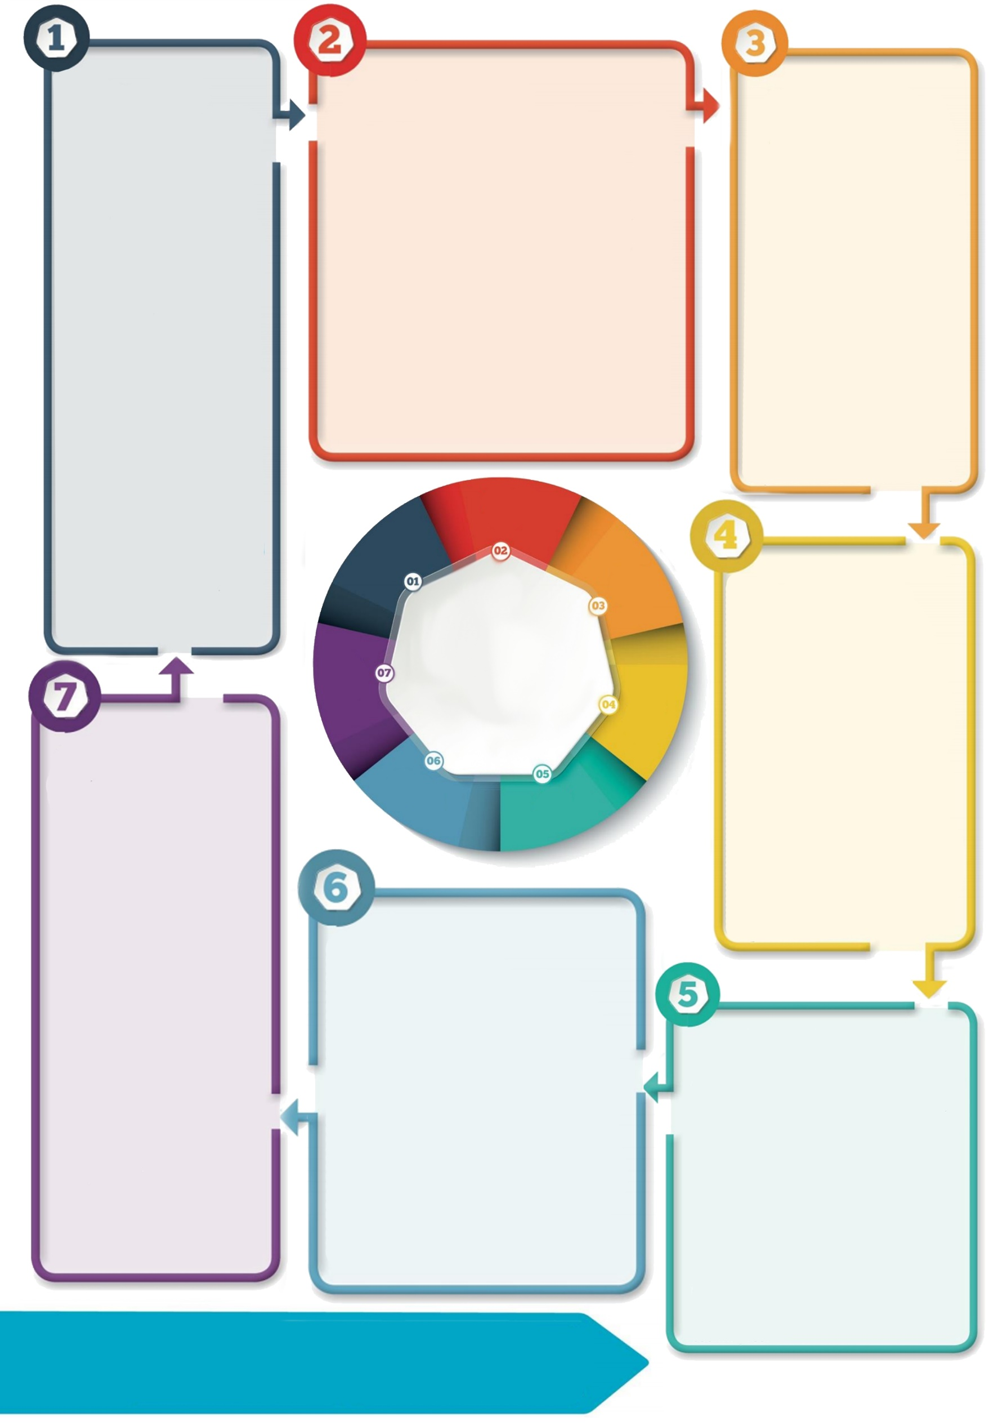

**Promote a sense   
of safety**

Autistic pupils may have taken the rhetoric around Covid-19 very literally and need reassurance that they are safe.

* Start by discussing what is the same (a reminder).
* Be clear, concise, consistent and factual, about what changes are happening and why. Scripts can be helpful for this. Share these before the pupil returns.
* Use social stories and visuals. to support understanding.
* Establish predictable routines and be explicit about these.

**A transition plan is key**

Do plan transition for individual Autistic pupils and communicate this plan to them well in advance, even if this means a delay in their start date. Work closely with parents to achieve this and to find out about the pupil’s lockdown experience.

Do establish a clear timeline of steps that are achievable, and which build towards the pupil’s new ‘normal’ routine. Detail start/finish times, how they will arrive and leave, how the day will be structured, who will be with them etc. Allow a practise run. Develop and share this with the family.

 **Don’t leave formulating a plan until the pupil is back at school. This could lead to heightened anxiety and other, associated difficulties.**

**Background**

Covid-19 and the subsequent closure of schools has led to routines being disrupted and an unfamiliar level of uncertainty .

The schools pupils return to from June will necessarily **look and feel** quite different to the ones they left in March.

This will be challenging for all, but Autistic pupils may feel these changes more keenly than most, due to key differences in their social understanding, information processing, sensory perception and social communication skills.

**Helping Autistic pupils transition back to school**



**Contact details: If you’d like to discuss further please contact the Educational Psychology Service (**[**EPS@salford.gov.uk**](mailto:EPS@salford.gov.uk) **or** [**educationpsychology@tameside.gov.uk**](mailto:educationpsychology@tameside.gov.uk)**)**

**Promote sensory calm**

Lockdown may have affected an Autistic pupil’s sensory needs. So too, might the new school routines/environment. They may seem over/under sensitive to (sometimes new) sensory input. This may lead to an increase/emergence of self-regulatory behaviours (stimming) and/or heightened anxiety shown through checking etc.

* Discuss with the pupil and their family, observe the pupil in multiple scenarios and update (create) their sensory profile.
* Carry out an environmental audit.
* Create a calm classroom and access to a sensory space.

**General strategies**

* Provide photos/ virtual tour before the pupil starts.
* Provide a personal postcard to welcome the pupil back.
* Focus on going over and mastering skills they have previous experience of, rather than new learning.
* Support pupils to express their lockdown experience. creatively.
* Consider ways to foster a feeling of belonging with the school i.e. clubs/class shield.

**Where next?**

[Autism, Communication, Education referral](https://www.salford.gov.uk/schools-and-learning/info-for-parents-students-and-teachers/special-educational-needs/learning-support-service/autism-communication-education-referral/) ACE Team

[Preparing Autistic &SEND children for going back to school](https://www.schudio.tv/courses/preparing-autistic-send-children-for-going-back-to-school) – 1hour free course.

**Emotional support**

Many will feel overwhelmed returning to school. Autistic pupils will feel this too and may also find their emotions difficult to recognise and process.

* Be aware that pupils may feel more anxious. Rehearse calming strategies with them.
* Provide emotional check-ins using visuals. Notice and name emotions explicitly.
* Use an Autism lens to consider what a pupil might be trying to communicate through their behaviour.
* Provide a safe space for a pupil who is dysregulated. Ensure they know where it is and how to access it.
* Listen to worries and normalise feelings.

**(Re-)establish social connections**

Pupils may have had little social interaction during lockdown. They may have lost skills and be anxious about seeing people again.

* Reduce social demands for chunks of the day and scaffold unstructured time.
* Practise social distancing routines.
* Plan and structure groupwork.
* Allow time to develop relationships with new staff. Plan a handover with the pupil and familiar staff.