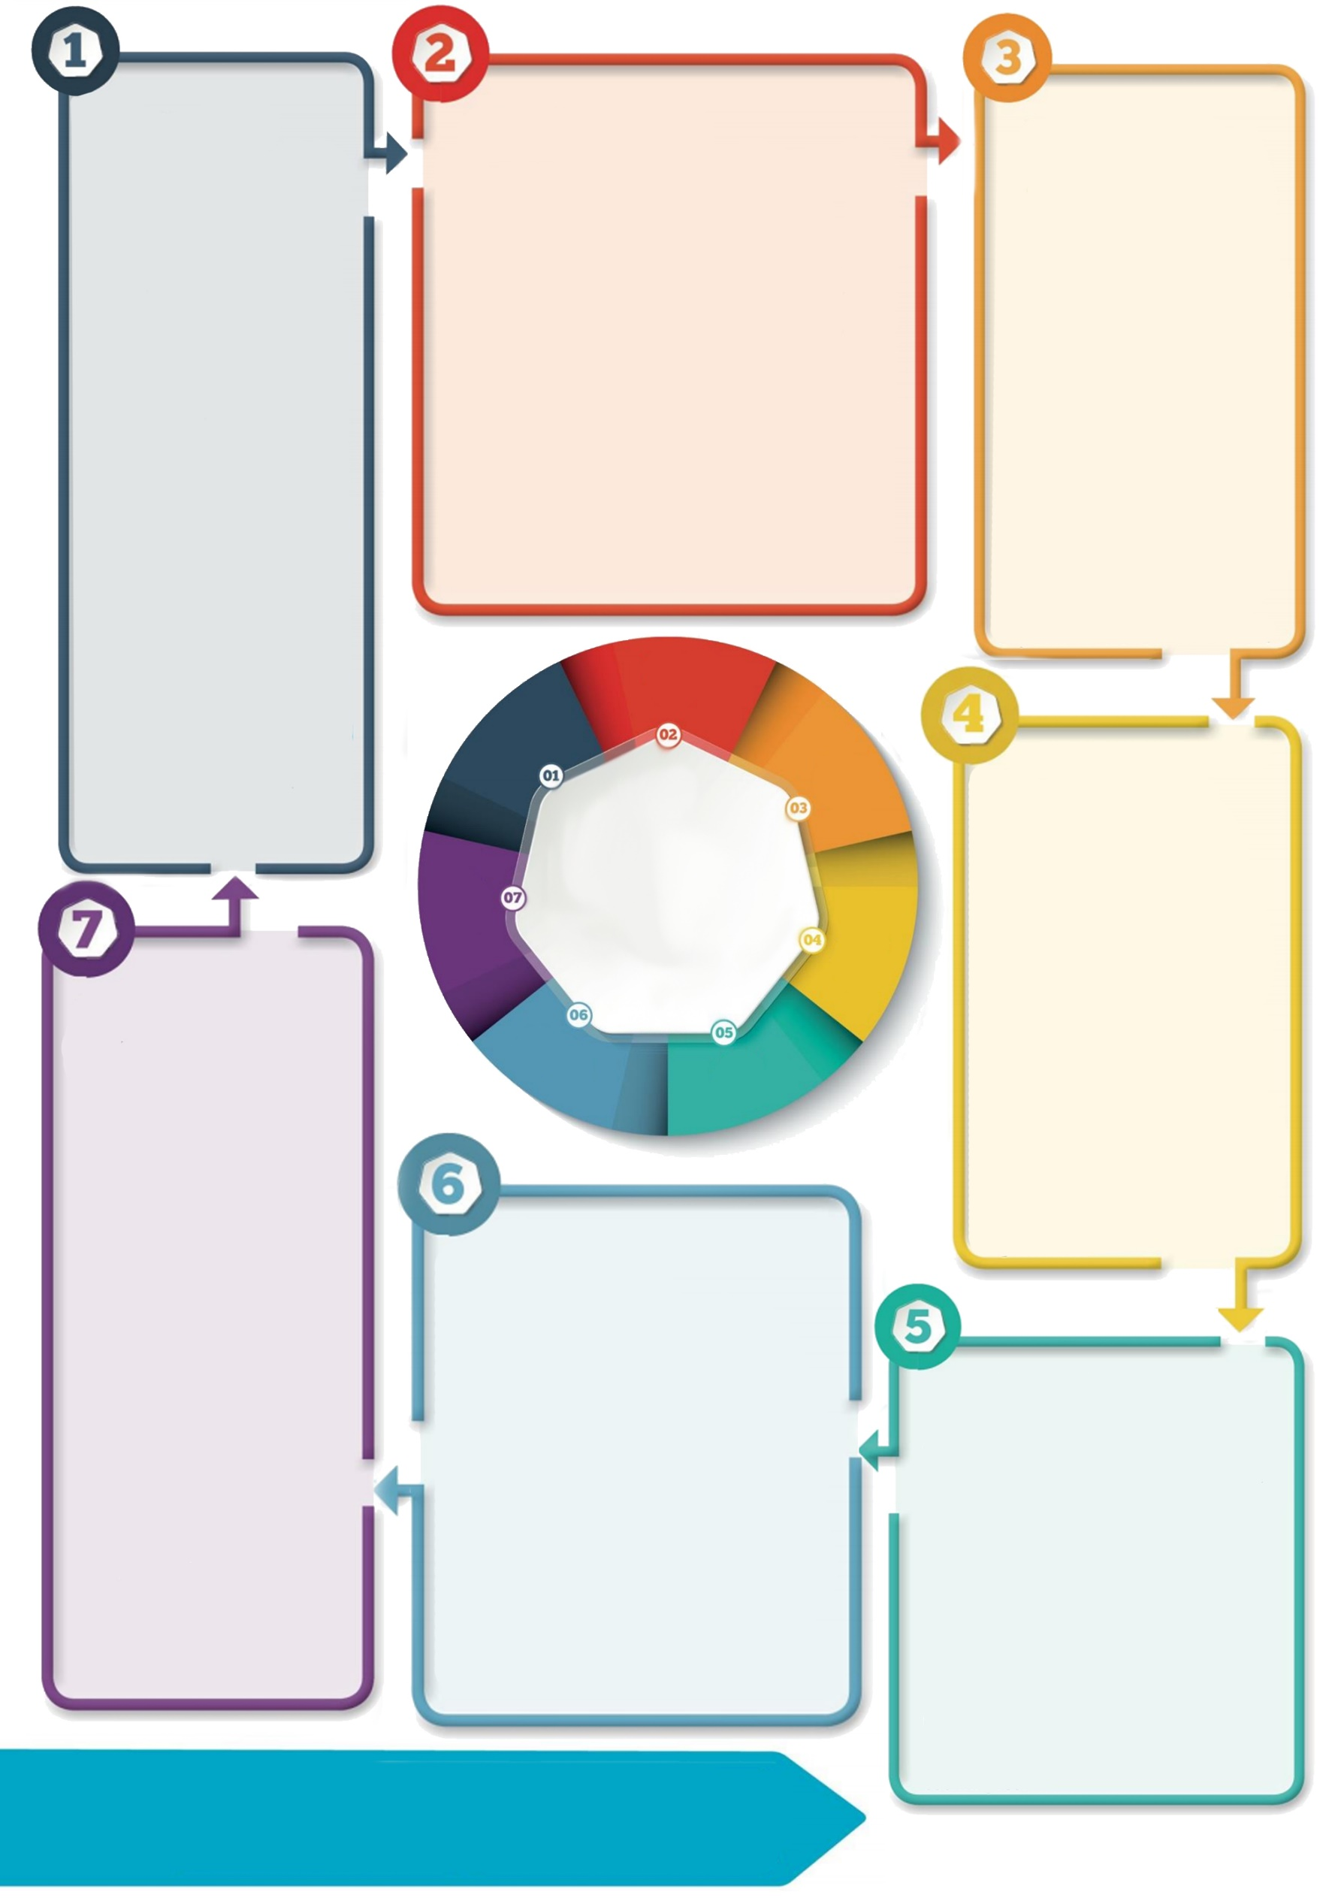

**Contact details: If you’d like to discuss further please contact the Educational Psychology Service (EPS@salford.gov.uk or educationpsychology@tameside.gov.uk)**

**What additional support may be required?**

**Increasing familiarity,** such as allowing children toreturn to their old classroom and/ or spend time with the class teacher they had previously.

**Increasing predictability**, through visual timetables, predictable routines, and recapping previously learnt material rather than introducing new concepts.

**Increasing a sense of connection to others**, through regular planned 1:1 or small group sessions.

**General support**

Under usual circumstances, this vulnerable group may require support with factors such as feeling safe; feeling a sense of belonging; feeling special; taking ‘risks’ required in learning; being self-aware and aware of others; and regulating their emotions. Their need for this type of support may have increased as a result of the Covid-19 pandemic, due to the increased uncertainty it has created.

**What to do when the transition involves a move to a new setting**

For some, the return to school will mean returning to a new setting entirely, such as those who are moving to high school in September. It will be crucial for them to have an opportunity to say goodbye to their previous setting. It will be important for pupils to have the chance to form relationships with key adults in their new setting, perhaps via virtual meetings, if appropriate. The pupil’s previous school should share important information with the receiving school so support can be planned for.

**Why might transition be particularly challenging for this group?**

When a child has experienced times where they have felt unsafe and lacked the presence of a caring adult to ‘buffer’ their experiences, transitions can trigger the anxiety and fear they have felt before (Fursland, 2013). This applies to large transitions, such as from school to school, but also smaller transitions, such as from task to task.

**What can I do to support transition for this vulnerable group?**

Ensure the general support advised by the EPS (see ‘Trauma-informed transition: Supporting the return to school’) is planned for **as a minimum.**

It may be helpful to allow children and young people to settle back in to school before learning begins. They may benefit from engaging in activities they usually enjoy and from increased nurture time with key adults.

**What is developmental trauma?**

Developmental trauma refers to repeated trauma experienced during childhood within long-term primary relationships. The type of experiences that might lead to developmental trauma may include abuse (emotional, physical and/ or sexual), neglect (emotional and/ or physical) and/ or domestic violence. Without the ‘buffer’ of a caring adult, these experiences can impact negatively on a child’s development. Children who have experienced this type of trauma may face increased challenges in relation to areas such as social, emotional and learning development.

**Transition**

**for children and young people who have experienced developmental trauma**

**Introduction**

This is an addendum to the ‘**Trauma-informed transition: Supporting the return to school**’ 7 minute briefing, which explores five key areas that support community recovery following a traumatic event.

This addendum builds on the advice contained in the Trauma-informed transition briefing whilst acknowledging that young people who have experienced trauma or adversity in their earlier years may require some additionality to the support offered to others. It aims to advise on the type of support that may be helpful.