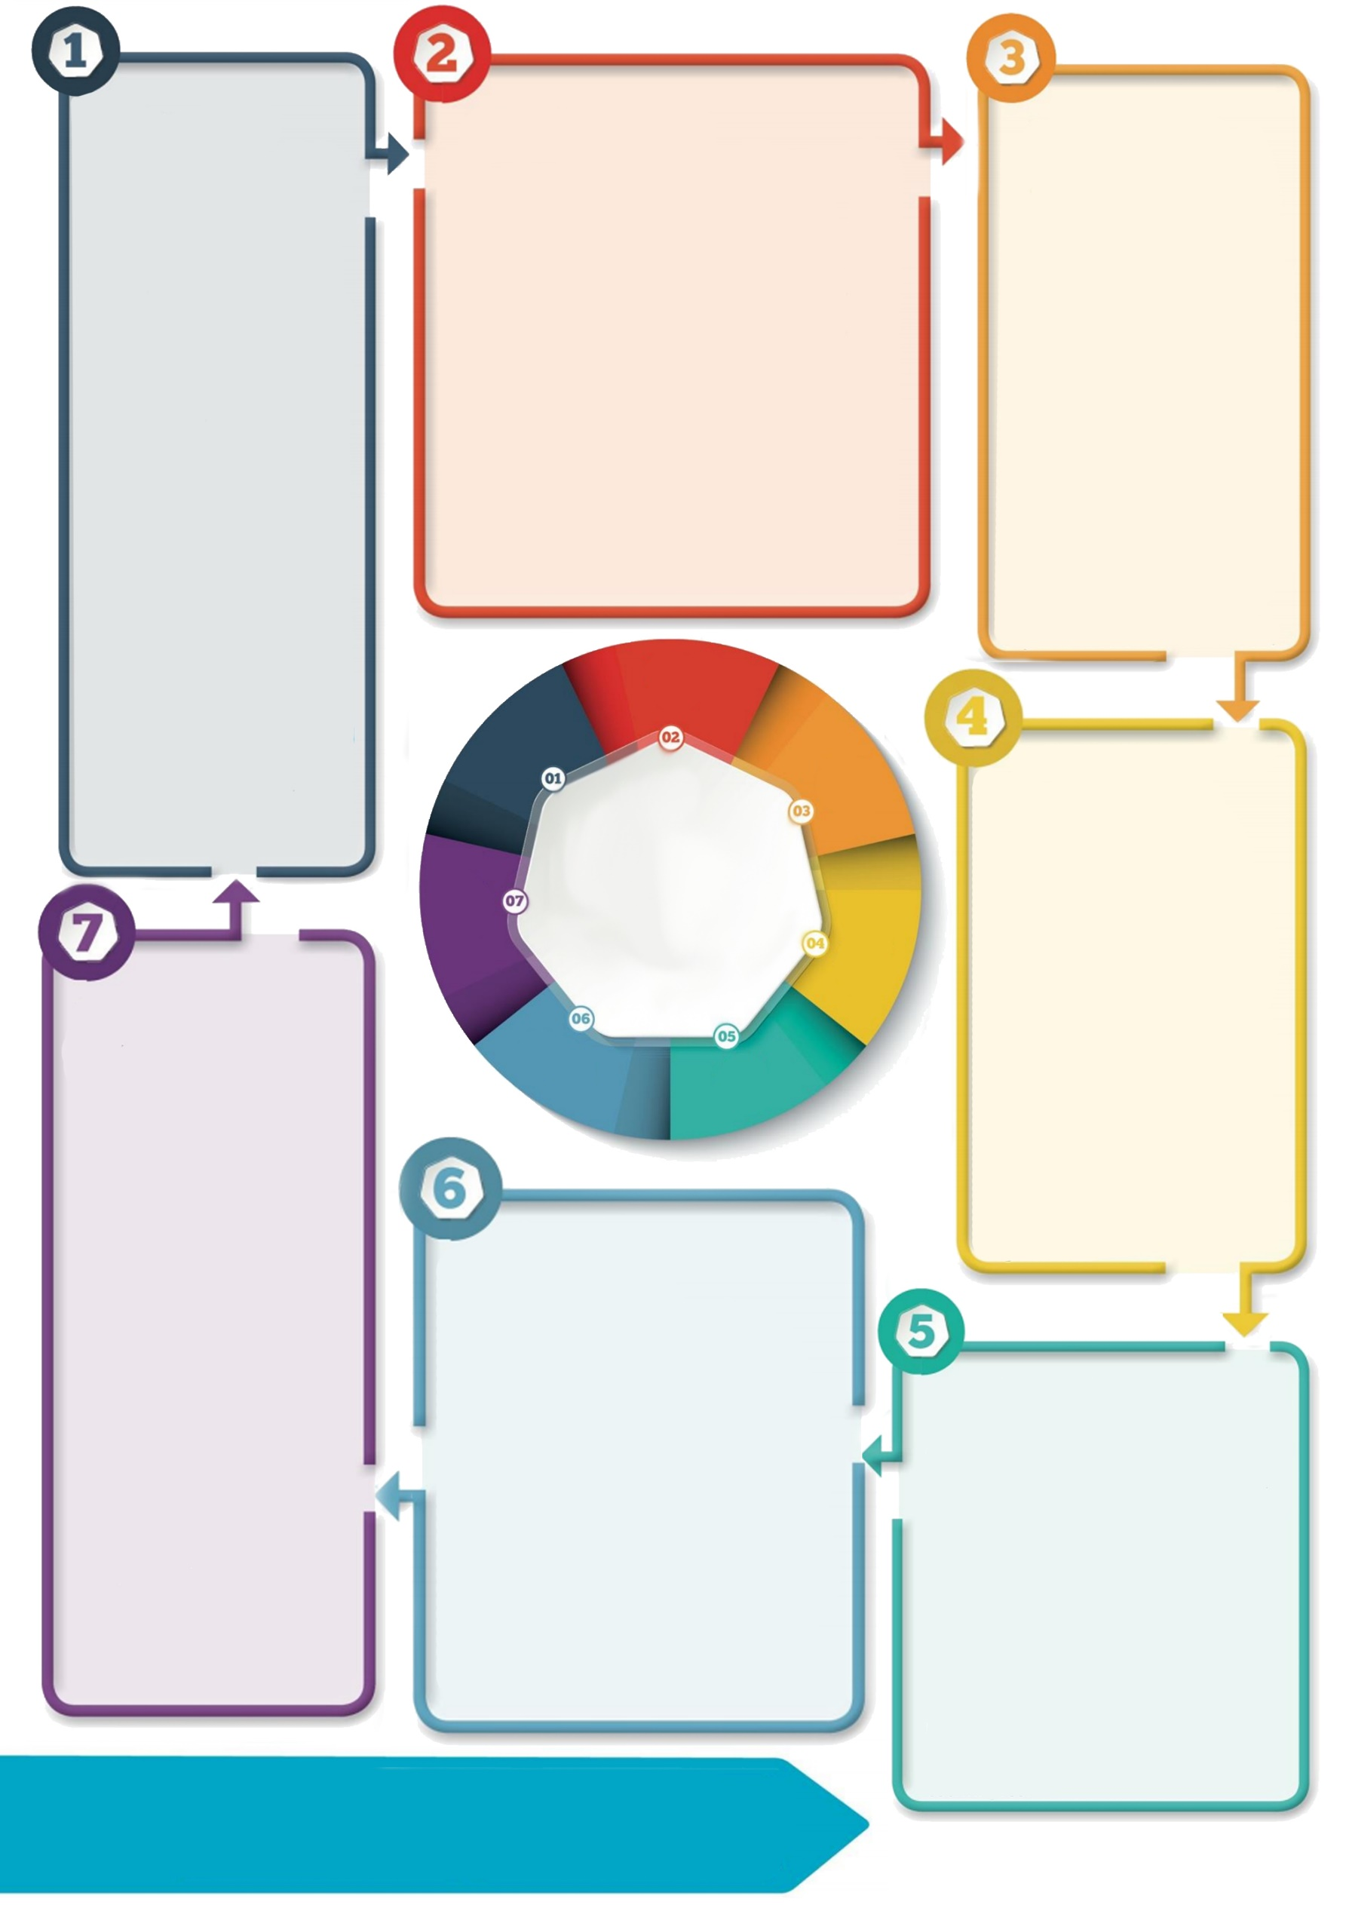

**Contact details: If you’d like to discuss further please contact the Educational Psychology Service (EPS@salford.gov.uk or educationpsychology@tameside.gov.uk)**

**Further thinking**

Considering how to promote each area in your setting, for staff as well as pupils, can help structure a plan for recovery. Some may find the transition back to school more difficult due to their differing strengths and needs. In addition to the universal support outlined here the EPS will be issuing additional briefings to support planning for those groups.

In order to support others’ psychological wellbeing, it is vital to focus on self-care first. Using the ‘oxygen mask’ analogy, without first attending to your own needs, you will be unable to care for others effectively.

**Hope**

Active hope is associated with resilience; an interaction between our own resources and relationships and support from others. Promote recovery and a vision of a preferred future, e.g.:

* Provide reassurance that in the longer term we will feel positive again.
* Reflect together on own and others’ skills and strengths. How can you notice, celebrate and magnify these?
* Share success stories, e.g. draw on hope and wisdom from current and historic events and people.
* Plan community projects involving visioning a positive future together.

**Trauma-informed transition**

**Supporting the return to school**

**Connectedness**

Rebuild and reinforce relationships within the school community, e.g.:

* Facilitate peer to peer connection e.g. buddies, circle time, tutorials.
* Allow opportunities for staff and pupils to reconnect through enjoyable activities e.g. baking, sports, arts and crafts, play.
* Model a sense of community through staff connectedness.
* Plan together how to show each other care when physically distanced.

**Self/collective efficacy**

Promote a feeling of control and a sense that our actions can have an impact, e.g.:

* Provide pupils with specific responsibilities and achievable tasks in school.
* Involve pupils in planning and implementing learning, social and community activities using communal language e.g. ‘our school/our project’.
* Provide opportunities for staff and pupils to share and celebrate successes and positives experienced during lockdown.

**Calm**

Promote a sense of calm, e.g.:

* Normalise, acknowledge, label and validate emotions.
* Use emotional regulation strategies such as mindfulness, music, yoga, sensory-based activities.
* Foster positive emotions like joy through play.
* Use coping tool reminders that are calming and have positive associations (e.g. images, objects, memories).
* Use timetabled check-ins

as a class, group and individually if needed.

**Safety**

Promote a sense of physical and psychological safety for all, e.g.:

* Acknowledge staff emotions. Give dedicated time for discussion and reflection with other staff, in a way that gives permission for a range of emotions to be expressed.
* Use transitional objects to help children feel connected to someone they love (e.g. a keyring or photo).
* Promote trust relationally by using

emotional validation techniques, including naming the child’s emotions, e.g. ‘I wonder

if you are feeling … because of ...’

* Give explicit messages around what you are doing to keep everyone safe.

**Introduction**

Transitions can be challenging, and the additional anxiety and disruption related to Covid-19 may add to the challenge of returning to school. A large study [Hobfoll *et al*. (2007)] found five key areas that support community recovery following a traumatic event: a sense of **safety, calm, self- and collective efficacy**, **connectedness** and **hope.** During this time, it will be vital to consider the **psychological wellbeing** of all members of the school community, including staff, children and young people, and parents and carers**.**